Accountable Care Organizations
Students Name
Institution Affiliation
Date of Submission

The outline of learning objectives
After addressing some aspects of Accountable Care Organizations, students should be able to;
- Gain new knowledge about Accountable Care Organizations (ACOs)
- Develop skills to enhance the effectiveness of Accountable Care Organizations (ACOs)
- Develop positive attitudes towards (ACOs)

Accountable Care Organization
Accountable Care Organization is a combination of healthcare services providers such as doctors and hospitals who voluntarily join together to provide high-quality care to Medicare patients at a low cost.. ACO operates in a coordinated manner that ensures their patients receive proper care at the right time to avoid unnecessary medical errors and duplication of services. The organizational structure of ACOs differs; for instance, in Alaska, ACOs comprise primary care physicians, private care providers, special care providers, and hospitals in various areas.
Healthcare providers in ACO coordinate effectively to improve on quality and efficiency of care. As an entity, ACO accounts for the total cost of care, and if it achieves quality performance and extra saving, it shares. However, some of the ACOs in Alaska, especially those that offer Medicaid, emanated from existing care delivery programs such as medical homes, PCCM and they already had a connection with care providers and developed the use of electronic medical records. One of the most ultimate benefits of ACOs is reducing the cost of healthcare.. In collaboration with federal regulations like the Affordable Care Act, ACOs have placed focus on reducing healthcare spending from a large population.
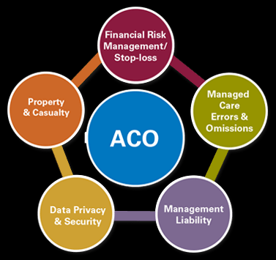
Additionally, ACOs have managed to improve population health through innovative approaches from care providers and achieve positive patient health outcomes. For example, Medicaid ACOs have placed their effort to prevent some diseases and infections and promote wellness, thus leading to health improvement. As a result, this reduces the chances of any illness or infection from emerging. More ACOs are coming up in the united states. Some health insurance companies have also partnered with hospitals and primary care providers through ACO. For example, Aetna partnered with the Delaware Valley Accountable Care Organization and agreed to an accountable care contract.

References
Crosson, F. J. (2011). The accountable care organization: whatever its growing pains, the concept is too vitally important to fail. Health Affairs, 30(7), 1250-1255.
Pham, H. H., Cohen, M., & Conway, P. H. (2014). The Pioneer accountable care organization model: improving quality and lowering costs. Jama, 312(16), 1635-1636.

Pham, H. H., Cohen, M., & Conway, P. H. (2014). The Pioneer accountable care organization model: improving quality and lowering costs. Jama, 312(16), 1635-1636.
Crosson, F. J. (2011). The accountable care organization: whatever its growing pains, the concept is too vitally important to fail. Health Affairs, 30(7), 1250-1255.

